**Nodejs Lab Assignment**

1. Install nodejs on your machine and use

npm init To create package.json file

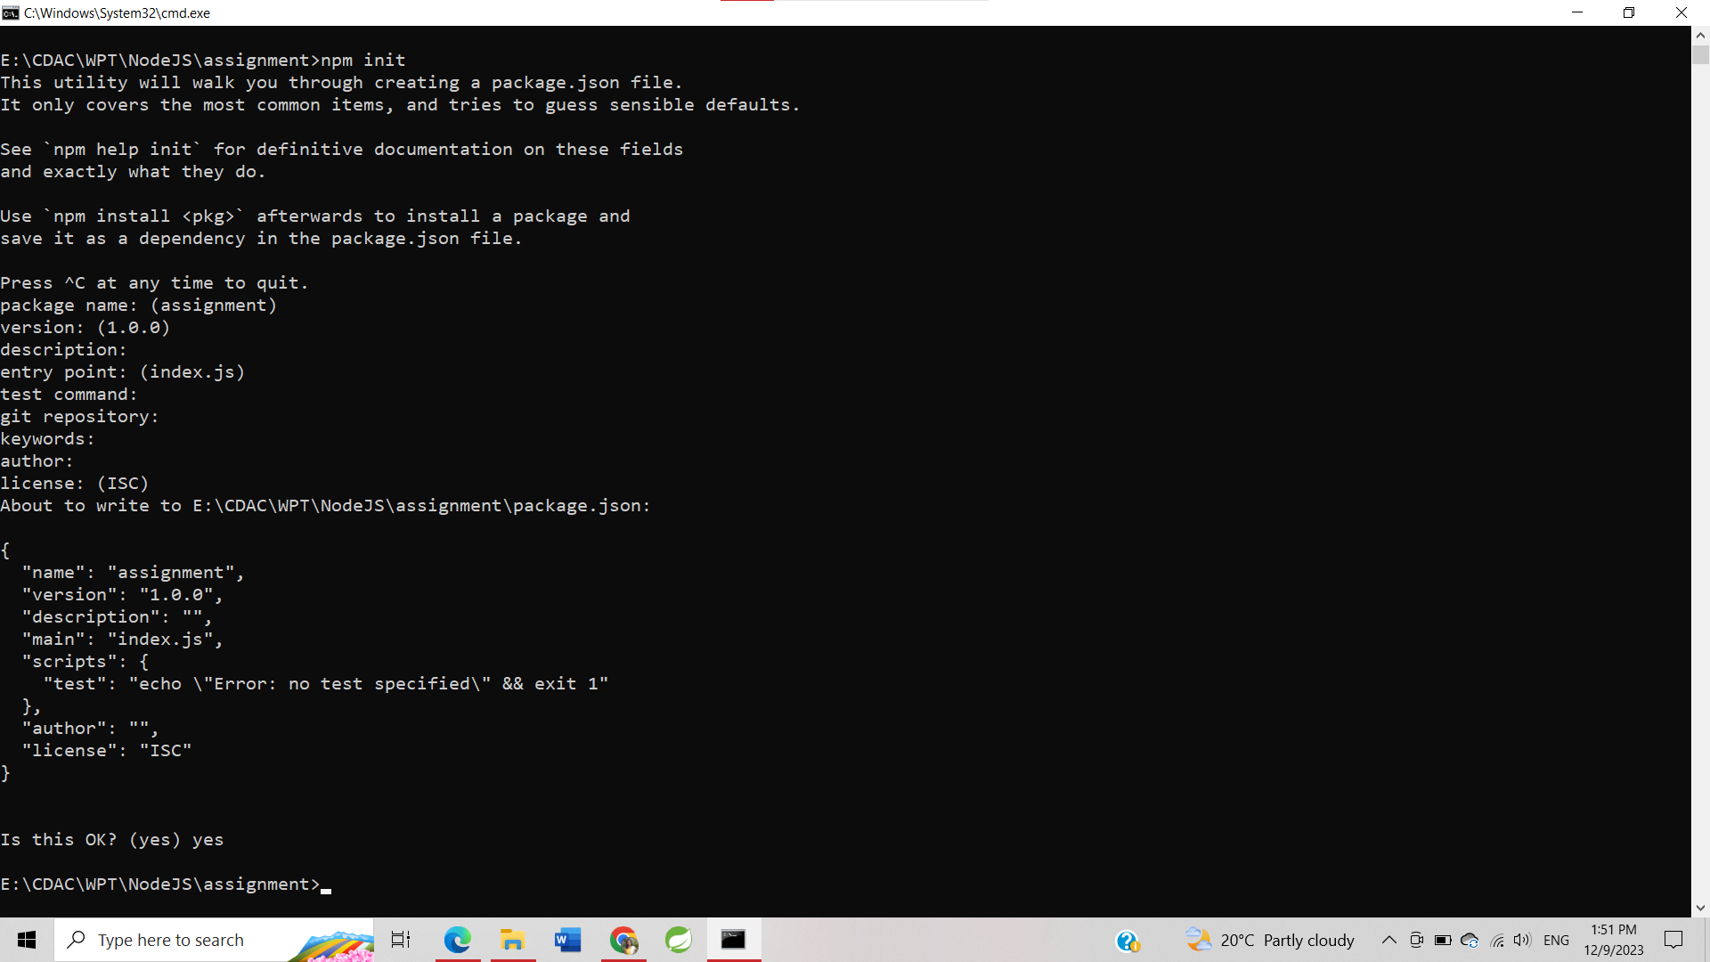

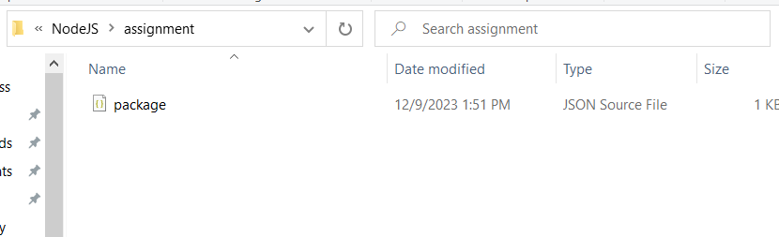

1. Add following dependancies in package.json file a. Express, body-parser, cookie-parser, jade

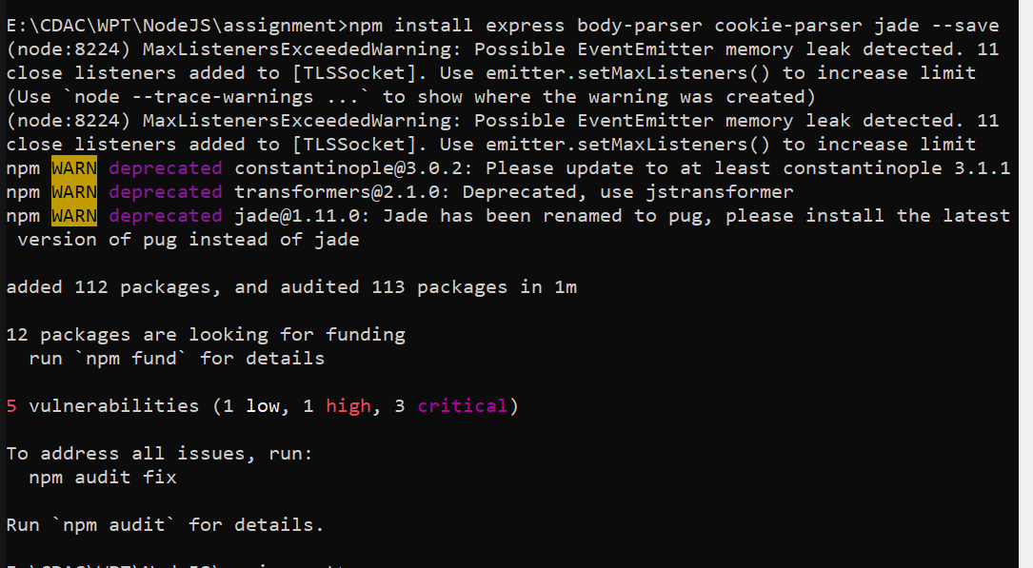

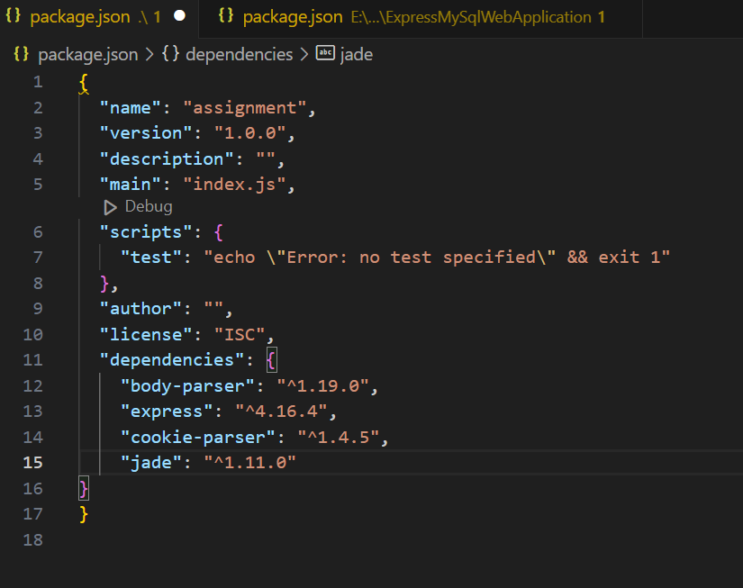

1. Install all dependancies by using command a. npm install b. see the node-module directory getting generated

